THE ECONOMY

Real gross state product (% change) | - Western Australia’s gross state product (GSP) of $285.6 billion in 2018-19 was 15% of Australia’s gross domestic product (GDP).  - GSP per capita of $109,565 in 2018-19 was 42% above Australia’s GDP per capita of $77,347.  - Real GSP rose 1.0% in 2018-19, below the rise of 2.5% in 2017-18, and below annual growth¹ of 3.5% over the past 10 years.  - The WA Government forecasts² real GSP growth of 3.0% in 2019-20 and 2.5% in 2020-21.  - Australia’s real GDP rose 1.9% in 2018-19. The Australian Government forecasts GDP growth of 2.25% in 2019-20 and 2.75% in 2020-21.
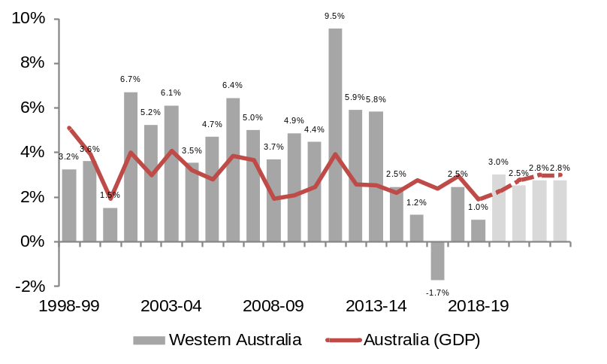
¹ Compound annual growth rate. ² WA Government 2019-20 Mid-year Financial Projections Statement.
Source: ABS 5220.0 State Accounts and 5204.0 National Accounts; WA Government 2019-20 Mid-year Financial Projections Statement (December 2019); and Australian Government 2019-20 Mid-Year Economic and Fiscal Outlook (December 2019).

Industry sectors (nominal gross value added) | - Goods producing industries accounted for 51% ($146.1b) of GSP in 2018-19. Services industries accounted for 39% ($112.4b), with the remaining 9% ($27.1b) from dwelling ownership and other items.  - Mining accounted for 36% of GSP in 2018-19, followed by business and property services (9%) and construction (6%).  - Manufacturing accounted for 5% of GSP in 2018-19.  - Agriculture, forestry and fishing accounted for 2% of GSP in 2018-19.
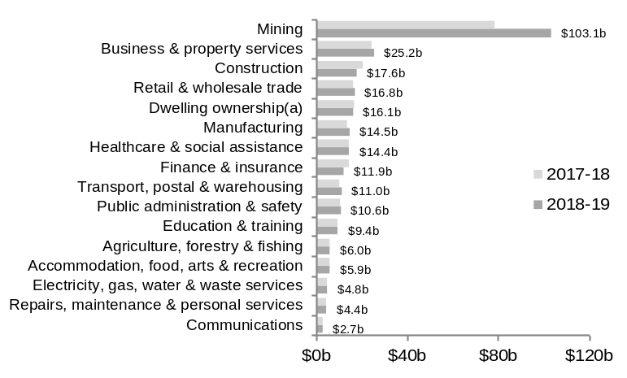
(a) Gross operating surplus of landlords and owner-occupiers (owner-occupiers are assigned a rent for their dwellings).
Source: ABS 5220.0 State Accounts.

Industry sectors contribution¹ to real GSP growth: 2018-19 | - Mining made the largest contribution to real GSP growth in 2018-19, with mining gross value added rising 8%. Business and property services was the next largest contributor (up 2%).  - Agriculture, forestry and fishing gross value added rose 1% in 2018-19.  - Construction was the largest detractor from GSP growth in 2018-19 (down 19%), followed by manufacturing (down 4.5%) and dwelling ownership (down 3%).
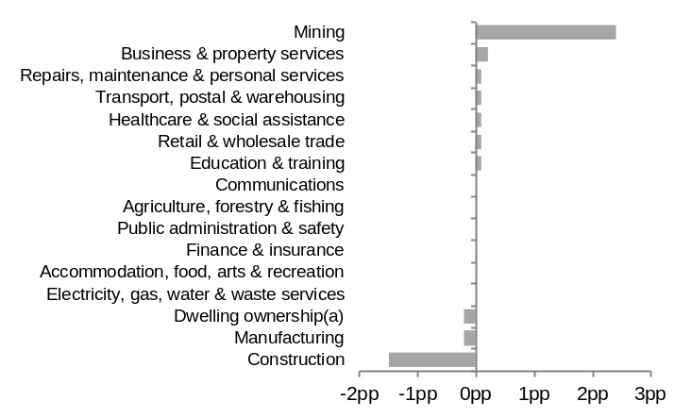
pp = percentage points. ¹ An industry’s contribution to real GSP growth depends on real changes to its gross value added and its share of GSP. (a) Gross operating surplus of landlords and owner-occupiers (owner-occupiers are assigned a rent for their dwellings).
Source: ABS 5220.0 State Accounts.

THE ECONOMY continued

Gross state income and terms of trade (% change) | - Changes in export prices relative to import prices (terms of trade) affects gross state income (GSI) and accounts for the difference between changes in GSI and GSP.  - Western Australia’s terms of trade rose 12% in 2018-19. This large increase meant that growth in Western Australia’s GSI was well above GSP in 2018-19.  - Real GSI rose 9% in 2018-19, above a rise of 2% in 2017-18, and above annual growth¹ of 3.7% over the past 10 years.  - The RBA’s annual average $A commodity price index for Australia rose 18% in 2018-19.
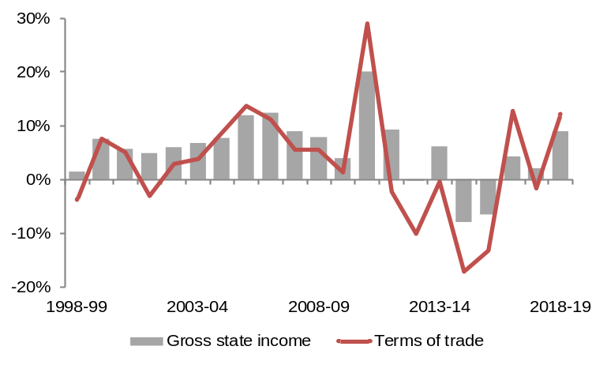
¹ Compound annual growth rate.
Source: ABS 5220.0 State Accounts.

Commodity prices¹ and exchange rate (monthly) | - The RBA’s monthly average $A commodity price index fell 2% in May 2020.  - The monthly average price of iron ore² rose 11% to US$94 a tonne in May 2020. The annual average price of iron ore² rose 16% to US$81 a tonne in 2018-19. It is forecast³ to be US$86 a tonne in 2019-20 and US$66 a tonne in 2020-21.  - The monthly average $A exchange rate rose 1% to US67 cents in May 2020. The annual average $A exchange rate fell 8% to US72 cents in 2018-19. It is forecast³ to be US68 cents in 2019-20 and US69 cents in 2020-21.
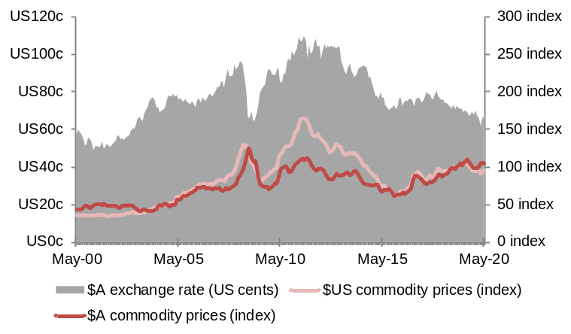
¹ Monthly index of commodity prices for Australia, 2017-18 = 100.0. ² China spot prices in nominal US dollars (cost and freight). ³ WA Government 2019-20 Mid-year Financial Projections Statement (December 2019).
Source: Reserve Bank of Australia, Statistical Tables.

Population growth¹ | - Western Australia’s population of 2.64 million in 2019 was 10% of Australia’s population.  - Population growth¹ of 1.3% (33,237) in 2019 was above growth of 0.9% in 2018, but below annual growth² of 1.5% over the past 10 years.  - Net overseas migration (up 18,862) and natural increase (18,499) offset a net loss from interstate migration (down 4,124) in 2019.  - Annual average population growth was 1.1% in 2018-19 and is forecast³ to rise to 1.3% in 2019-20 and 1.5% in 2020-21.  - The WA Tomorrow report forecasts a population of 3.25 million by 2031.
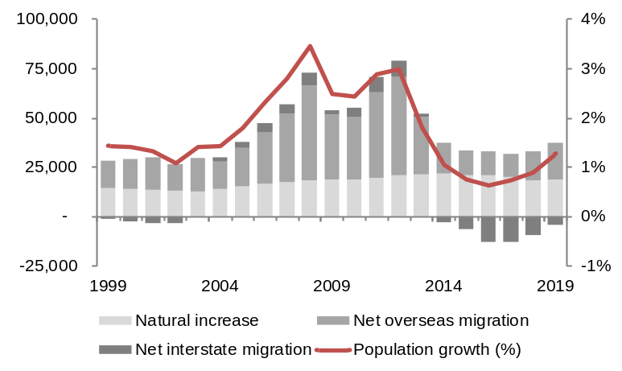
Note – Components of population change may not sum to total population growth due to intercensal difference. ¹ Through the year. ² Compound annual growth rate. ³ WA Government 2019-20 Mid-year Financial Projections Statement (December 2019).
Source: ABS 3101.0 Australian Demographic Statistics.

LABOUR MARKET

Labour market indicators: May 2020 | - Western Australia’s total employment was 1.27 million in May 2020, 59.7% of the civilian working age population. Full-time employment accounted for 70% of total employment in May 2020.  - The COVID-19 pandemic has had a major effect on the State’s labour market. The number of employed persons fell by 30,241 in May 2020.  - The unemployment rate of 8.1% in May 2020 was above the 6.1% in the previous month and 6.2% a year ago. The number of unemployed persons rose by 27,944 in May 2020.  - Australia’s unemployment rate was 7.1% in May 2020.
 | Reference month⁶ | Change from: |  | Annual average⁷ | Change from:
 | May.  2020 | Apr. 2020 | May. 2019 | 12 months to May.2020 | 12 months to May.2019
Employed full-time¹ (‘000) | 896 | +2 | -29 | 917 | -5
Employed part-time² (‘000) | 376 | -32 | -43 | 434 | +14
Total employed (‘000) | 1,272 | -30 | -72 | 1,351 | +8
Participation rate³ (%) | 65.0 | -0.1 | -3.1 | 67.7 | -0.6
Employment to population ratio (%) | 59.7 | -1.4 | -4.2 | 63.8 | -0.4
Unemployed (‘000) | 112 | +28 | +23 | 84 | -4
Unemployment rate⁴ (%) | 8.1 | +2.0 | +1.9 | 5.8 | -0.3
Underemployed (‘000) | 168 | -33 | +41 | 142 | +9.9
Underemployment rate⁵ (%) | 12.1 | -2.3 | +3.3 | 9.9 | +0.7

¹ Worked 35 hours or more a week. ² Worked less than 35 hours a week. ³ The proportion of the civilian working age population (aged 15 and older) in the labour force (people who are either employed or unemployed). ⁴ The proportion of the labour force that is unemployed (people without a job who are actively looking for work). ⁵ The proportion of the labour force that is underemployed (workers wanting more hours). ⁶ Seasonally adjusted. ⁷ Original.
Source: ABS 6202.0 Monthly Labour Force.

Employment growth (annual average) | - Western Australia’s annual average employment growth was 0.9% (12,690) in 2019, below the 1.5% (19,233) growth in 2018.  - In 2019, annual average full-time employment rose by 12,907 to 922,588 while annual average part-time employment fell by 216 to 429,782.  - Annual average employment growth is forecast¹ to rise from 0.9% in 2018-19 to 1.5% in 2019-20 and 1.75% in 2020-21.  - Annual average employment growth was 0.6% (8,452) for the 12 months to May 2020.
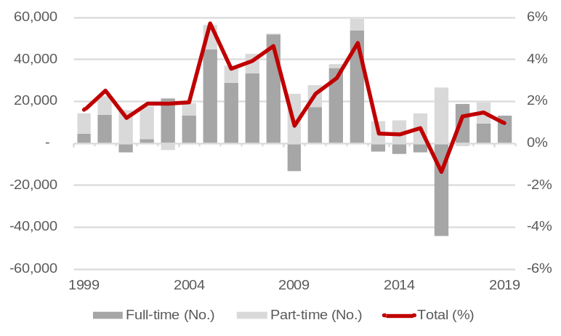
¹ WA Government 2019-20 Mid-year Financial Projections Statement (December 2019).
Source: ABS 6202.0 Monthly Labour Force.

Employment by industry (annual average) | - Services industries accounted for 72% of total employment in 2019-20 and goods-producing industries accounted for 28%, including construction (9%) and mining (8%).  - Business and property services (up 8,113) and mining (up 6,209) had the largest increases in annual average employment in 2019-20.  - Accommodation, food, arts and recreation (down 14,094) and manufacturing (down 9,992) had the largest falls in annual average employment in 2019-20.
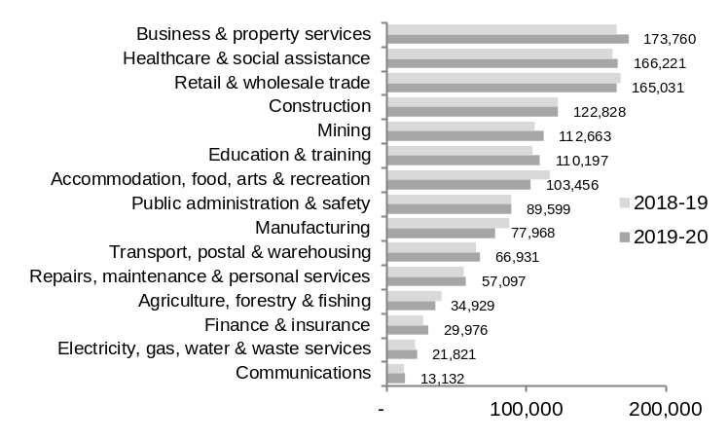
Source: ABS 6291.0.55.003 Quarterly Labour Force.

LABOUR MARKET continued

Participation rate and job vacancies (quarterly) | - The participation rate of 68.2% in the March quarter 2020 was above the 68.1% in the previous quarter and the 68.0% a year ago.  - The annual average participation rate was 68.3% in 2018-19 and is forecast¹ to be 68.2% in 2019-20 and 68.3% in 2020-21.  - There were 16,800 job vacancies² in the June quarter 2020, 10,800 less than in the previous quarter and 6,400 less than a year ago.
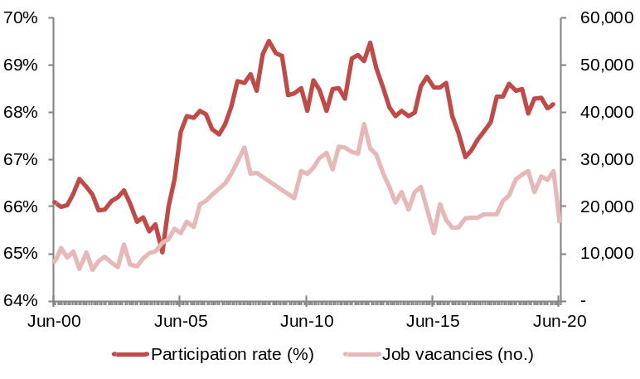
¹ WA Government 2019-20 Mid-year Financial Projections Statement (December 2019). ² Not adjusted for seasonal factors.
Source: ABS 6202.0 Monthly Labour Force; and 6354.0 Job Vacancies.

Underutilisation rate (annual average) | - Western Australia’s annual average unemployment rate was 5.9% in 2019, below the 6.2% in 2018.  - The annual average unemployment rate was 6.1% in 2018-19 and is forecast¹ to fall to 5.75% in 2019-20 and 5.75% in 2020-21.  - The annual average underemployment rate was 9.2% in 2019, below the 9.3% in 2018.  - Australia’s annual average unemployment rate was 5.2% in 2019.  - For the 12 months to May 2020, Western Australia’s annual average unemployment rate was 5.8% and annual average underemployment rate was 9.9%.
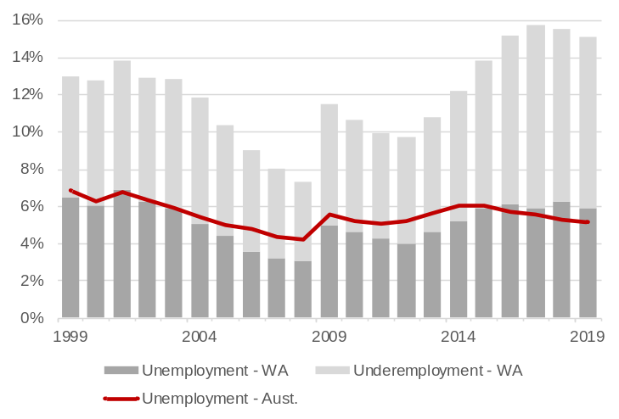
¹ WA Government 2019-20 Mid-year Financial Projections Statement (December 2019).
Source: ABS 6202.0 Monthly Labour Force.

Average annual earnings and wages growth¹ | - Average annual adult full-time total earnings rose 1% to $96,647 in 2019.  - Western Australia’s average annual adult full-time total earnings were 8% ($7,062) above the Australian average of $89,586 in 2019.  - Western Australia’s wage price index rose 1.7% in 2019, below annual growth² of 2.5% over the past 10 years, and below Australia’s wages growth of 2.2% in 2019.  - Western Australia’s wage price index rose 1.6% in 2018-19 and is forecast³ to rise to 2.0% in 2019-20 and 2.25% in 2020-21.
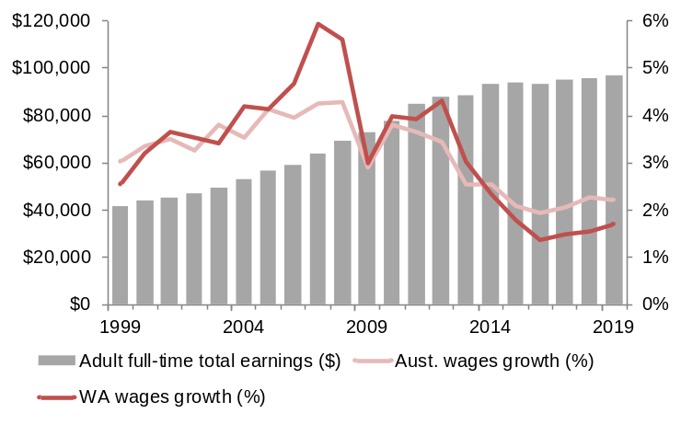
¹ Changes in average weekly earnings and the wage price index differ mainly because the wage price index holds labour quality (job specifications and employee performance and experience) and quantity (hours worked and employee numbers) constant.
² Compound annual growth rate. ³ WA Government 2019-20 Mid-year Financial Projections Statement (December 2019).
Source: ABS 6302.0 Average Weekly Earnings; and 6345.0 Wage Price Index (2008-09 = 100.0).

CONSUMPTION

Real household consumption (% change) | - Western Australia accounted for 10% of Australia’s household consumption in 2019.  - Household consumption accounted for 38% of GSP in 2018-19 and contributed 0.4 percentage points to real GSP growth.  - Real household consumption rose 1.3% in 2019, in line with the rise of 1.3% in 2018, but below annual growth¹ of 2.7% over the past 10 years.  - Real household consumption growth was 1.0% in 2018-19 and is forecast² to rise to 1.25% in 2019-20 and 2.25% in 2020-21.
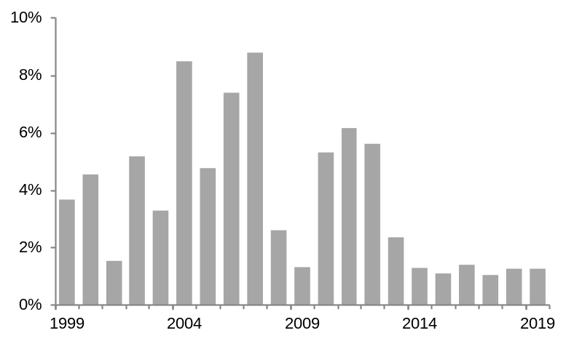
¹ Compound annual growth rate. ² WA Government 2019-20 Mid-year Financial Projections Statement (December 2019).
Source: ABS 5220.0 State Accounts; and 5206.0 Quarterly National Accounts.

Household consumption by industry sector (nominal) | - Nominal household consumption rose 2.5% to $111.2 billion in 2019.  - The largest increases in household consumption in 2019 were in insurance, finance and other (up $628m or 4%), food (up $413m or 4%) and health (up $263m or 3%).  - The largest decreases in household consumption in 2019 were in furnishings and household equipment (down $31m or 1%) and communications (down $27m or 1%).
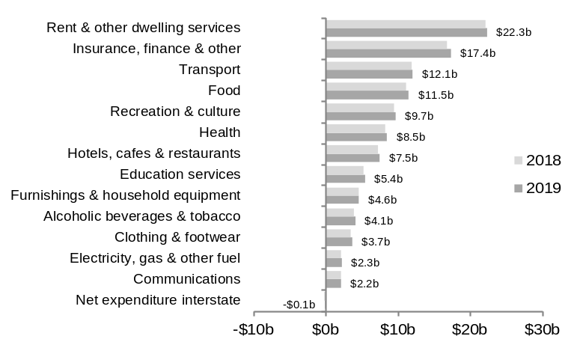
Source: ABS 5220.0 State Accounts; and 5206.0 Quarterly National Accounts.

Gross household disposable income per capita | - Western Australia’s gross household disposable income per capita of $53,641 in 2018-19 was 9% ($4,543) above the Australian average of $49,098.  - Gross household disposable income per capita fell 0.1% in 2018-19, following a rise of 1% in 2017-18, and compared with annual growth¹ of 3% over the past 10 years.  - Total gross household disposable income rose by $1.1 billion in 2018-19, due to increases in employee wages (up $2.5b), social benefits and other secondary income (up $298m) and self-employed and property income (up $255m), partially offset by a rise interest and tax paid on secondary income (up $1.9b).
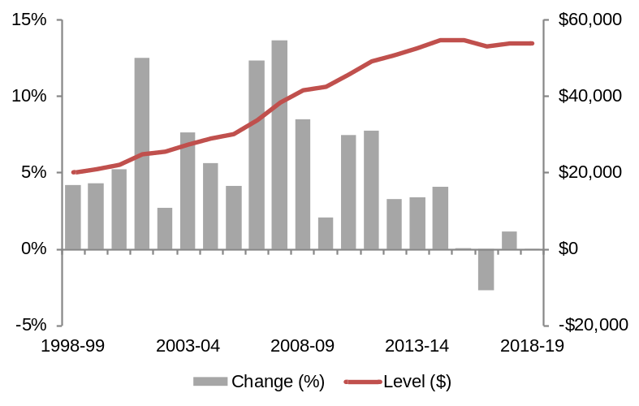
¹ Compound annual growth rate.
Source: ABS 5220.0 State Accounts.
INVESTMENT

Investment (nominal) | - Western Australia accounted for 16% of Australia’s business investment in 2019.  - Business investment accounted for 12% of GSP in 2018-19 and detracted 1.3 percentage points from real GSP growth.  - Real business investment fell 1% in 2019, following a fall of 7% in 2018.  - Real business investment fell 7% in 2018-19, but is forecast¹ to rise 6% in 2019-20 and 7% in 2020-21.  - Nominal business investment rose 1% to $36.4 billion in 2019.  - Nominal dwelling investment fell 11% to $7.8 billion in 2019.  - Nominal public investment rose 3% to $8.9 billion in 2019.
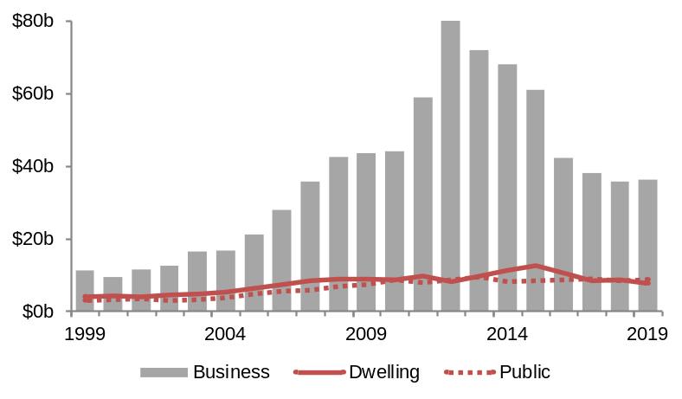
¹ WA Government 2019-20 Mid-year Financial Projections Statement (December 2019).
Source: ABS 5220.0 State Accounts; and 5206.0 Quarterly National Accounts.

Private new capital expenditure | - Western Australia accounted for 51% of Australia’s mining new capital expenditure in 2019.  - Mining accounted for 70% of Western Australia’s private new capital expenditure in 2019.  - Mining new capital expenditure fell 3% to $17.2 billion in 2019.  - New capital expenditure in other selected industries fell 7% to $7.2 billion in 2019.  - In March 2020, Western Australia had $27.2 billion of major resource projects under construction or committed and $91.1 billion under consideration.
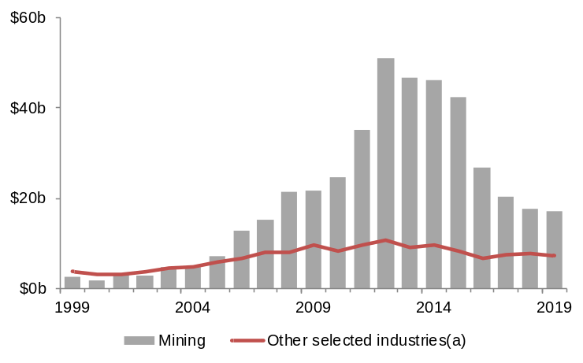
(a) Includes manufacturing and other industries except for agriculture, forestry and fishing; public administration and safety; education and training; healthcare and social assistance; and superannuation funds.
Source: ABS 5625.0 Private New Capital Expenditure.

Exploration expenditure | - Western Australia accounted for 62% of Australia’s minerals exploration expenditure in 2019.  - Western Australia accounted for 54% of Australia’s petroleum exploration expenditure in 2019.  - Minerals exploration expenditure rose 25% to $1.7 billion in 2019, mainly due to increases in copper and gold exploration.  - Petroleum exploration expenditure rose 12% to $750 million in 2019.
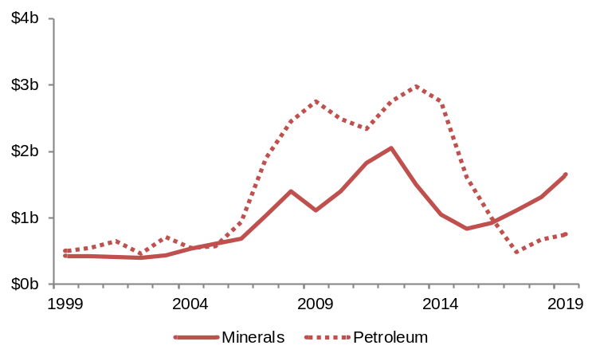
Source: ABS 8412.0 Mineral and Petroleum Exploration.

PROPERTY MARKET AND CONSTRUCTION ACTIVITY

Median established house prices and rents (quarterly) | - Perth’s median established house price fell 5.0% to $477,000 in the March quarter 2020. It fell 4.6% through the year to the March quarter 2020.  - The rest of Western Australia’s (excluding Perth) median established house price fell 0.4% to $333,500 in the March quarter 2020. It fell 0.4% through the year to the March quarter 2020.  - Perth rents fell 0.1% in the March quarter 2020 and fell 0.6% through the year to the March quarter 2020.
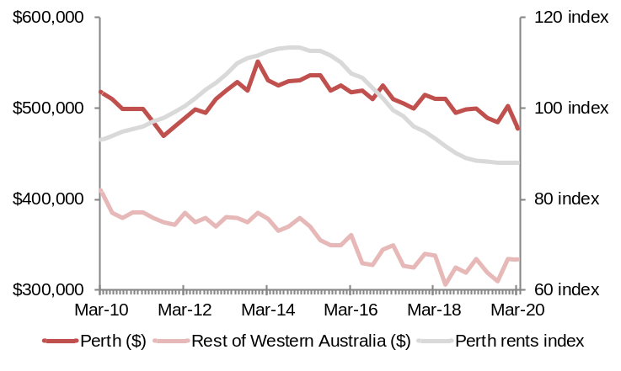
Source: ABS 6416.0 Residential Property Price Indexes; and 6401.0 Consumer Price Index (2011-12 = 100.0).

Building and engineering construction activity | - Residential building activity fell 13% to $5.1 billion in 2019.  - Non-residential building activity fell 0.5% to $4.0 billion in 2019.  - Heavy industry engineering construction activity fell 17% to $9.7 billion in 2019.  - Other engineering construction activity fell 10% to $6.1 billion in 2019, mainly due to a decrease in the construction of roads, highways and subdivisions, and telecommunications infrastructure.
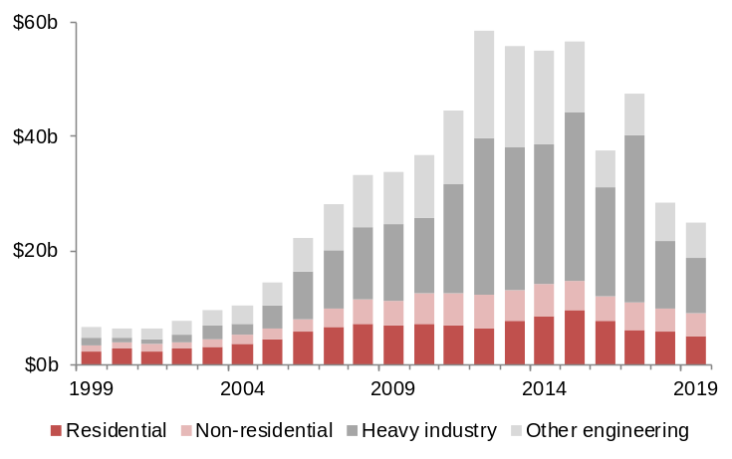
Source: ABS 8752.0 Building Activity; and 8762.0 Engineering Construction Activity.

Building construction activity outlook (quarterly) | - Western Australia had $5.6 billion of building activity in the pipeline¹ in the December quarter 2019, above the $5.5 billion in the same quarter of 2018.  - Residential building approvals rose 1% to $1.2 billion in the March quarter 2020. Residential building approvals typically lead building activity by one to two quarters.  - Non-residential building approvals rose 51% to $1.2 billion in the March quarter 2020.  - Housing finance for dwelling construction rose 1% to $558 million in the March quarter 2020. Housing finance typically leads residential building activity by two to three quarters.
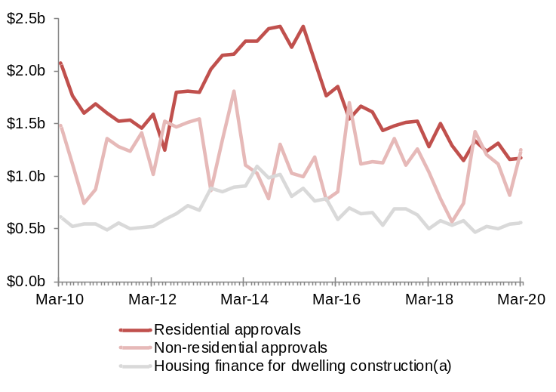
(a) New loan commitments by owner-occupiers. Not adjusted for seasonal factors.
Source: ABS 8731.0 Building Approvals; and 5601.0 Lending Indicators.

MERCHANDISE EXPORTS

Merchandise exports (nominal) | - Western Australia accounted for 46% of Australia’s merchandise exports in 2019.  - Merchandise exports accounted for 58% of GSP in 2018-19 and contributed 0.8 percentage points to real GSP growth.  - Real merchandise exports rose 0.1% in 2019, below a rise of 7% in 2018.  - Real merchandise exports rose 1% in 2018-19 and is forecast² to rise 4% in 2019-20 and 1.5% in 2020-21.  - Nominal merchandise exports rose 25% to $182.2 billion in 2019.
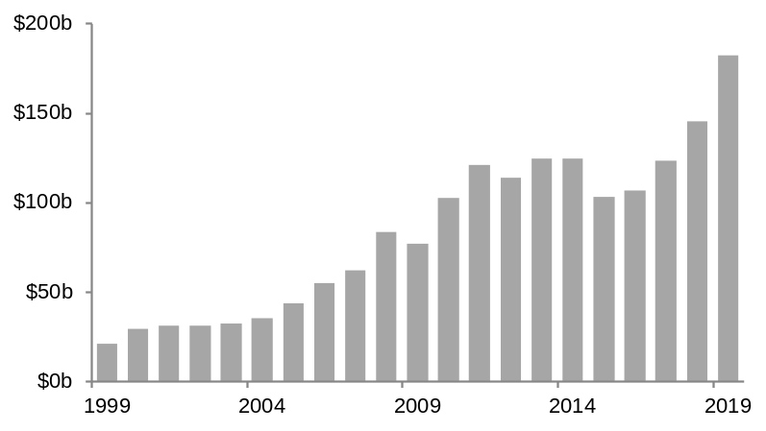
¹ Compound annual growth rate. ² WA Government 2019-20 Mid-year Financial Projections Statement (December 2019).
Source: ABS 5368.0 International Trade in Goods and Services; 5220.0 State Accounts; and 5206.0 Quarterly National Accounts.

Major export markets (top 10) | - Western Australia’s largest export market in 2019 was China ($96.1b or 53%), followed by Japan ($24.0b or 13%) and the United Kingdom ($12.4b or 7%).  - Western Australia had majority shares of Australia’s exports to the United Kingdom (82%), China (64%), Singapore (63%) and Hong Kong (51%) in 2019.  - Minerals and petroleum accounted for 94% ($170.9b) of merchandise exports in 2019.  - Agriculture, food, fibre, fisheries and forestry¹ accounted for 5% ($8.3b) of merchandise exports in 2019.
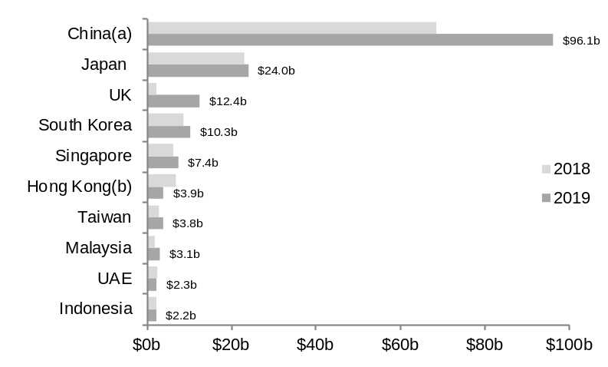
¹ Excludes confidential items. (a) Excludes Special Administrative Regions and Taiwan. (b) Special Administrative Region of China.
Source: ABS 5368.0 International Trade in Goods and Services.

Major export commodities: 2019
Iron ore | $m (%) | Petroleum¹ | $m (%) | Gold | $m (%) | Alumina² | $m (%) | Nickel ore | $m (%)
China^{(a)} | 78,719 (82) | Japan | 15,231 (41) | UK | 11,984 (58) | UAE | 1,838 (27) | China^{(a)} | 1,784 (44)
Japan | 7,159 (7) | China^{(a)} | 6,162 (17) | Hong Kong^{(b)} | 3,396 (16) | Bahrain | 923 (13) | Japan | 424 (11)
South Korea | 5,992 (6) | Singapore | 5,969 (16) | China^{(a)} | 2,991 (15) | South Africa | 644 (9) | Malaysia | 367 (9)
Other | 3,875 (5) | Other | 9,730 (26) | Other | 2,233 (11) | Other | 3,511 (51) | Other | 1,455 (36)
Total | 95,746 (100) | Total | 37,091 (100) | Total | 20,604 (100) | Total | 6,916 (100) | Total | 4,030 (100)

Wheat | $m (%) | Copper ore³ | $m (%) | Lithium⁴ | $m (%) | Chemicals⁵ | $m (%) | Mineral sands⁶ | $m (%)
Philippines | 612 (22) | China^{(a)} | 982 (49) | China^{(a)} | 1,289 (91) | Thailand | 163 (12) | China^{(a)} | 557 (47)
South Korea | 407 (14) | Philippines | 268 (13) | Belgium | 69 (5) | China^{(a)} | 142 (10) | USA | 77 (6)
Japan | 312 (11) | Japan | 225 (11) | USA | 22 (2) | Japan | 130 (10) | UK | 74 (6)
Other | 1,486 (53) | Other | 534 (27) | Other | 35 (3) | Other | 924 (68) | Other | 471 (40)
Total | 2,816 (100) | Total | 2,009 (100) | Total | 1,416 (100) | Total | 1,358 (100) | Total | 1,179 (100)

Note – Components may not add to totals due to rounding. ¹ LNG, condensate, crude oil and LPG. ² Includes bauxite. ³ Includes concentrates. ⁴ Mainly spodumene. Includes other crude minerals. ⁵ Mainly titanium dioxide pigments, aluminium hydroxide, silicon, ammonia and medicaments. ⁶ Includes garnet, illmenite, leucoxene, zircon and rutile. (a) Excludes Special Administrative Regions and Taiwan. (b) Special Administrative Region of China.
Source: WA Department of Mines, Industry Regulation and Safety, Resource Data Files; and ABS 5368.0 International Trade in Goods and Services.

SERVICES EXPORTS

Services exports (nominal) | - Western Australia accounted for 7% of Australia’s services exports in 2018-19.  - Services exports accounted for 2% of GSP in 2018-19 and detracted 0.03 percentage points from real GSP growth.  - Real services exports rose 2% in 2019 compared with annual decline¹ of 1% over the past five years.  - Nominal services exports rose 1% to $6.7 billion in 2018-19.
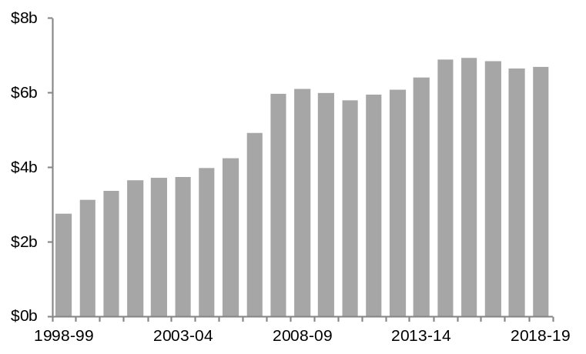
¹ Compound annual growth rate.
Source: ABS 5220.0 State Accounts; and 5368.0.55.003/004 International Trade in Services by State.

Services exports by industry sector (top 6) | - Services exports mainly comprised personal travel (34%) and education-related travel (30%) and transport (14%) in 2018-19.  - The largest increase in 2018-19 was in technical, trade-related and other business services (up 56%), while the largest decline was in telecommunications, computer and information services (down 63%).  - International student enrolments rose 4% to 53,459 in 2019, above annual growth¹ of 1% over the past 10 years.  - Western Australia accounted for 5.6% of Australia’s international student enrolments in 2019, below the 5.9% share in 2018.
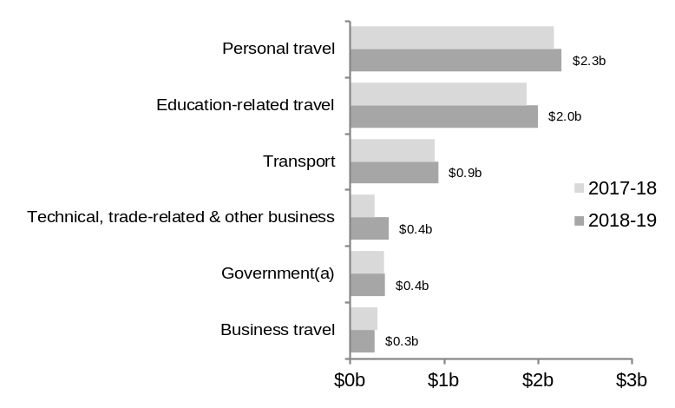
(a) Goods and services purchased in Western Australia by international embassies, consulates, military units and defence agencies, and personal expenditures of diplomats, consular and military staff and their dependants. ¹ Compound annual growth rate.
Source: ABS 5368.0.55.003/004 International Trade in Services by State.

Overnight visitors | - Tourism¹ accounted for 2.5% ($6.5b) of GSP and 5.5% (73,200) of total employment in 2017-18.  - Total overnight visitors¹ rose 11% to 12 million in 2019, above annual growth² of 7% over the past 10 years.  - Total visitor spending^{(a)} rose 15% to $11.0 billion in 2019.  - In 2019:  - International overnight visitors rose 3% to 995,732 and their spending rose 7% to $2.4 billion.  - Domestic overnight visitors rose 12% to 11 million and their spending rose 15% to $6.2 billion.  - Local residents spending on day trips rose 22% to $2.4 billion.
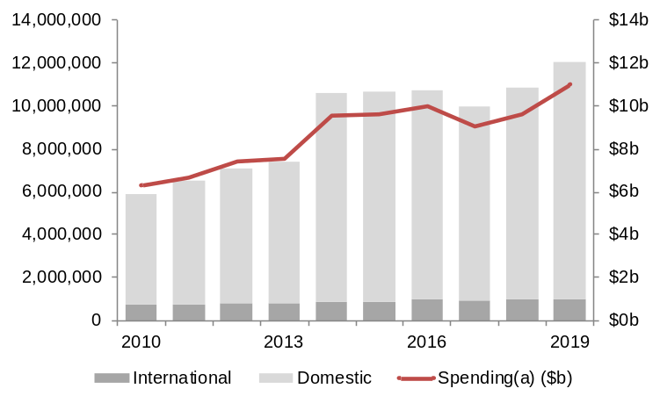
Note – Break in series in 2014 and 2018. (a) Spending by international and domestic overnight visitors and Western Australian residents on daytrips. ¹ International and domestic. ² Compound annual growth rate.
Source: Tourism Research Australia, International and National Visitor Surveys.

MINING

Western Australia’s share of Australian and world mining production: 2019
 | Unit | World % share | Aust. % share | WA | Australia | World
Iron ore | million tonnes | 32 | 99 | 810 | 819 | 2,500
Garnet | ‘000 tonnes | 29 | 100 | 353 | 353 | 1,200
LNG | million tonnes | 13 | 59 | 44 | 75 | 348
Rare earths | ‘000 tonnes | 12 | 100 | 26 | 26 | 210
Zircon | ‘000 tonnes | 12 | 31 | 171 | 550 | 1,400
Diamonds | million carats | 11 | 100 | 16 | 16 | 147
Alumina | million tonnes | 11 | 69 | 14 | 20 | 132
Gold | tonnes | 6 | 67 | 219 | 324 | 3,464
Nickel | ‘000 tonnes | 6 | 100 | 154 | 154 | 2,700
Illmenite¹ | ‘000 tonnes | 5 | 54 | 359 | 660 | 7,000
Cobalt | ‘000 tonnes | 4 | 100 | 6 | 6 | 140
Salt | million tonnes | 4 | 88 | 11 | 13 | 293

¹ Excludes ilmenite feedstock for synthetic rutile production. ² Excludes synthetic rutile. Source: WA Department of Mines, Industry Regulation and Safety, Resource Data Files.

Mining gross value added (nominal) | - Western Australia is the main exporter of minerals and petroleum in Australia and produces a significant proportion of the world’s minerals and petroleum commodities.  - Western Australia accounted for 56% of Australia’s mining gross value added in 2018-19, above its 52% share in the previous year, but below its 67% share in 2013-14.  - Mining accounted for 36% of GSP in 2018-19, above its 30% share in the previous year, but below its 37% share in 2010-11.  - Nominal mining gross value added rose 32% to $103.1 billion in 2018-19, above annual growth¹ of 7% over the past 10 years.
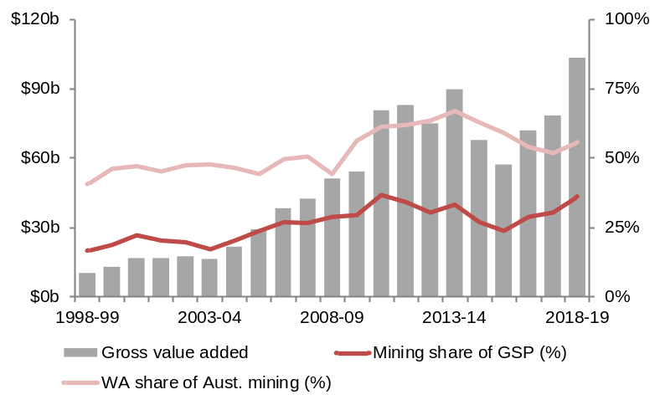
¹ Compound annual growth rate.
Source: ABS 5220.0 State Accounts.

Major minerals and petroleum sales | - Iron ore accounted for 58% of minerals and petroleum sales in 2019, followed by:  - LNG (16%)  - Gold (8%)  - Condensate (4%)  - Alumina and bauxite (4%)  - Nickel (2%)  - Crude oil (2%)  - Natural gas (1%)  - Base metals (1%)  - Lithium (1%)  - The value of minerals and petroleum sales rose 28% to $167.3 billion in 2019, mainly due to an increase in the value of iron ore sales.
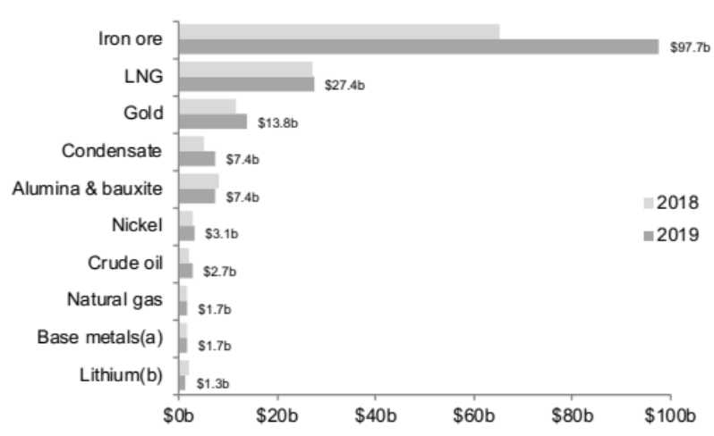
(a) Copper, lead and zinc (contains gold and silver).
Source: WA Department of Mines, Industry Regulation and Safety, Resource Data Files.

MINING continued

Iron ore sales | - Iron ore sales rose 50% to $97.7 billion in 2019, due to rising average prices offsetting falling sales volumes.  - The volume of iron ore sales fell 0.4% to 810 million tonnes in 2019, compared with annual growth¹ of 9% over the past 10 years.  - The annual average $A unit price (free on board) of iron ore sales rose 50% in 2019.  - Western Australia’s iron ore sales are forecast² to rise to 862 million tonnes by 2022-23.
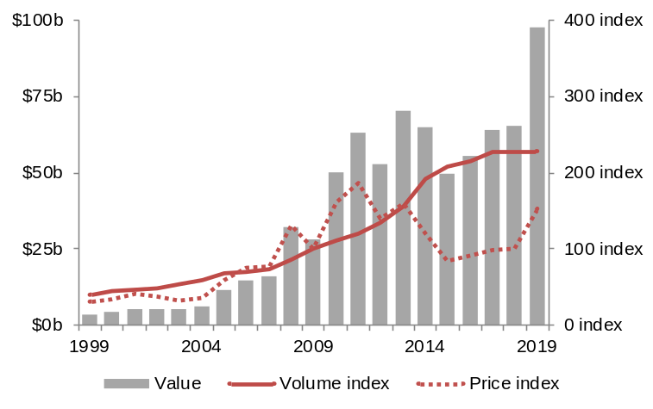
¹ Compound annual growth rate. ² WA Government 2019-20 Mid-year Financial Projections Statement (December 2019).
Source: WA Department of Mines, Industry Regulation and Safety, Resource Data Files (2009 = 100.0).

LNG sales | - LNG sales rose 2% to $27.4 billion in 2019, due to rising sales volumes and average prices.  - The volume of LNG sales rose 1% to 44 million tonnes in 2019, below annual growth¹ of 11% over the past 10 years.  - The annual average $A unit price (free on board) of LNG sales rose 1% in 2019.
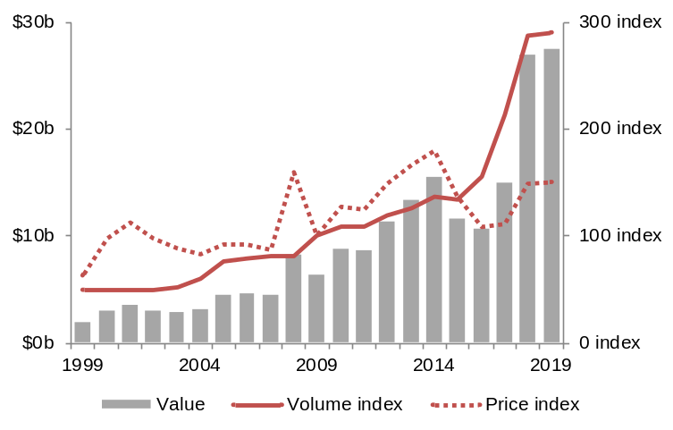
¹ Compound annual growth rate.
Source: WA Department of Mines, Industry Regulation and Safety, Resource Data Files (2009 = 100.0).

Gold sales | - Western Australia’s gold sales rose 20% to $13.8 billion in 2019, due to rising average prices and sales volumes.  - The volume of gold sales rose 3% to 219 tonnes in 2019, compared with annual growth¹ of 4% over the past 10 years.  - The annual average $A unit price (free on board) of gold sales rose 16% in 2019.
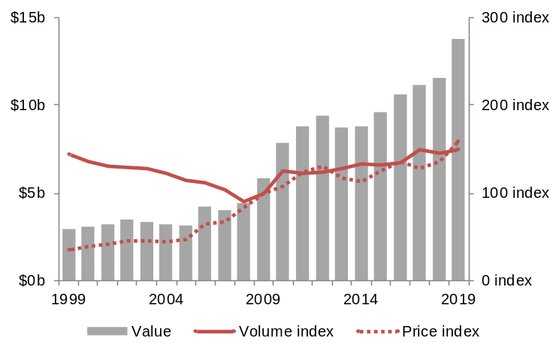
¹ Compound annual growth rate.
Source: WA Department of Mines, Industry Regulation and Safety, Resource Data Files (2009 = 100.0).

REGIONS
Perth Metropolitan Area |  | Annual¹ |  | Quarter² | Share³
Population 2018-19 | 1,949,753 | +24,306 | +1.3% | - | 74.4%
Employed Dec-19 | 996,899 | +16,334 | +1.7% | +0.6% | 76.2%
Unemployed Dec-19 | 64,691 | -2,356 | -3.5% | -3.3% | 78.5%
Unemployment rate Dec-19 | 6.1% | -0.3pp | - | -0.2pp | -
Gross regional product 2018-19 | $173.8b | +$10.9b | +6.7% | - | 60.8%
Minerals & petroleum sales 2019 | $5.4b | -$476m | -8.0% | - | 3.3%
Agriculture production 2015-16 | $457m | - | - | - | 5.6%
Residential building 2018-19 | $3.9b | -$678m | -14.8% | - | 77.8%
Non-residential building 2018-19 | $3.1b | -$228m | -6.9% | - | 80.1%
Overnight visitors 2016 to 2018 | 4,320,000pa | - | - | - | 34.8%

South West |  | Annual¹ |  | Quarter² | Share³
Population 2018-19 | 179,791 | +1,415 | +0.8% | - | 6.9%
Employed Dec-19 | 92,487 | -3,590 | -3.7% | -0.2% | 7.1%
Unemployed Dec-19 | 4,379 | -1,063 | -19.5% | +4.4% | 5.3%
Unemployment rate Dec-19 | 4.5% | -0.8pp | - | +0.2pp | -
Gross regional product 2018-19 | $14.2b | +$839m | +6.3% | - | 5.0%
Minerals & petroleum sales 2019 | $3.8b | +$654m | +21.0% | - | 2.3%
Agriculture production 2015-16 | $801m | - | - | - | 9.8%
Residential building 2018-19 | $452m | -$2m | -0.3% | - | 9.0%
Non-residential building 2018-19 | $196m | +$34m | +20.8% | - | 5.1%
Overnight visitors 2016 to 2018 | 2,581,400pa | - | - | - | 20.8%

Great Southern |  | Annual¹ |  | Quarter² | Share³
Population 2018-19 | 60,993 | +167 | +0.3% | - | 2.3%
Employed Dec-19 | 31,100 | +2,329 | +8.1% | -0.1% | 2.4%
Unemployed Dec-19 | 1,069 | -47 | -4.2% | -5.3% | 1.3%
Unemployment rate Dec-19 | 3.3% | -0.4pp | - | -0.2pp | -
Gross regional product 2018-19 | $4.1b | +$65m | +1.6% | - | 1.4%
Minerals & petroleum sales 2019 | $8m | -$0m | -0.7% | - | 0.05%
Agriculture production 2015-16 | $1.2b | - | - | - | 14.4%
Residential building 2018-19 | $104m | -$18m | -14.7% | - | 2.1%
Non-residential building 2018-19 | $62m | -$0m | -0.2% | - | 1.6%
Overnight visitors 2016 to 2018 | 747,600pa | - | - | - | 6.0%

Wheatbelt |  | Annual¹ |  | Quarter² | Share³
Population 2018-19 | 73,437 | -380 | -0.5% | - | 2.8%
Employed Dec-19 | 31,718 | +2,281 | +7.7% | -0.2% | 2.4%
Unemployed Dec-19 | 1,100 | -48 | -4.2% | -6.0% | 1.3%
Unemployment rate Dec-19 | 3.4% | -0.4pp | - | -0.2pp | -
Gross regional product 2018-19 | $7.1b | +$503m | +7.7% | - | 2.5%
Minerals & petroleum sales 2019 | $1.2b | +$90m | +8.4% | - | 0.7%
Agriculture production 2015-16 | $3.4b | - | - | - | 40.9%
Residential building 2018-19 | $89m | -$27m | -23.0% | - | 1.8%
Non-residential building 2018-19 | $52m | -$61m | -54.0% | - | 1.4%
Overnight visitors 2016 to 2018 | 1,006,600pa | - | - | - | 8.1%

Mid West |  | Annual¹ |  | Quarter² | Share³
Population 2018-19 | 52,941 | -706 | -1.3% | - | 2.0%
Employed Dec-19 | 20,653 | -1,776 | -7.9% | -1.3% | 1.6%
Unemployed Dec-19 | 1,881 | -272 | -12.6% | -2.2% | 2.3%
Unemployment rate Dec-19 | 8.3% | -0.4pp | - | -0.1pp | -
Gross regional product 2018-19 | $8.2b | +$1.1b | +16.2% | - | 2.9%
Minerals & petroleum sales 2019 | $4.7b | +$1.1b | +29.0% | - | 2.8%
Agriculture production 2015-16 | $972m | - | - | - | 11.9%
Residential building 2018-19 | $46m | -$18m | -28.5% | - | 0.9%
Non-residential building 2018-19 | $38m | -$28m | -42.4% | - | 1.0%
Overnight visitors 2016 to 2018 | 720,300pa | - | - | - | 5.8%

Goldfields-Esperance |  | Annual¹ |  | Quarter² | Share³
Population 2018-19 | 54,363 | -746 | -1.4% | - | 2.1%
Employed Dec-19 | 22,433 | -1,957 | -8.0% | -1.3% | 1.7%
Unemployed Dec-19 | 995 | -113 | -10.2% | -1.8% | 1.2%
Unemployment rate Dec-19 | 4.2% | -0.1pp | - | -0.0pp | -
Gross regional product 2018-19 | $18.0b | +$3.4b | +23.3% | - | 6.3%
Minerals & petroleum sales 2019 | $12.9b | +$1.3b | +10.9% | - | 7.7%
Agriculture production 2015-16 | $870m | - | - | - | 10.6%
Residential building 2018-19 | $55m | -$16m | -22.4% | - | 1.1%
Non-residential building 2018-19 | $64m | -$11m | -14.5% | - | 1.6%
Overnight visitors 2016 to 2018 | 680,500pa | - | - | - | 5.5%

Pilbara and offshore |  | Annual¹ |  | Quarter² | Share³
Population 2018-19 | 62,093 | +420 | +0.7% | - | 2.4%
Employed Dec-19 | 30,088 | -3,029 | -9.1% | -1.9% | 2.3%
Unemployed Dec-19 | 945 | -39 | -4.0% | -1.6% | 1.1%
Unemployment rate Dec-19 | 3.0% | +0.2pp | - | +0.0pp | -
Gross regional product 2018-19 | $46.6b | +$9.2b | +24.6% | - | 16.3%
Minerals & petroleum sales 2019 | $137.0b | +$36.9b | +36.8% | - | 81.9%
Agriculture production 2015-16 | $137m | - | - | - | 1.7%
Residential building 2018-19 | $24m | +$6m | +34.2% | - | 0.5%
Non-residential building 2018-19 | $189m | -$60m | -24.3% | - | 4.9%
Overnight visitors 2016 to 2018 | 936,800pa | - | - | - | 7.5%

Gascoyne |  | Annual¹ |  | Quarter² | Share³
Population 2018-19 | 9,277 | -144 | -1.5% | - | 0.4%
Employed Dec-19 | 4,454 | -494 | -10.0% | -1.7% | 0.3%
Unemployed Dec-19 | 421 | +15 | +3.7% | -1.4% | 0.5%
Unemployment rate Dec-19 | 8.6% | +1.1pp | - | +0.0pp | -
Gross regional product 2018-19 | $1.5b | +$188m | +14.9% | - | 0.5%
Minerals & petroleum sales 2019 | $98m | +$12m | +14.4% | - | 0.1%
Agriculture production 2015-16 | $80m | - | - | - | 1.0%
Residential building 2018-19 | $9m | -$1m | -11.6% | - | 0.2%
Non-residential building 2018-19 | $11m | -$15m | -57.1% | - | 0.3%
Overnight visitors 2016 to 2018 | 337,400pa | - | - | - | 2.7%

Kimberley |  | Annual¹ |  | Quarter² | Share³
Population 2018-19 | 35,901 | -104 | -0.3% | - | 1.4%
Employed Dec-19 | 13,930 | -1,709 | -10.9% | -2.3% | 1.1%
Unemployed Dec-19 | 2,688 | +187 | +7.5% | +4.0% | 3.3%
Unemployment rate Dec-19 | 16.2% | +2.4pp | - | +0.8pp | -
Gross regional product 2018-19 | $3.0b | +$242m | +8.7% | - | 1.1%
Minerals & petroleum sales 2019 | $705m | +$325m | +85.4% | - | 0.4%
Agriculture production 2015-16 | $313m | - | - | - | 3.8%
Residential building 2018-19 | $30m | -$43m | -59.2% | - | 0.6%
Non-residential building 2018-19 | $44m | +$20m | +79.6% | - | 1.1%
Overnight visitors 2016 to 2018 | 412,700pa | - | - | - | 3.3%

Peel |  | Annual¹ |  | Quarter² | Share³
Population 2018-19 | 142,960 | +3,100 | +2.2% | - | 5.5%
Employed Dec-19 | 64,287 | +4,211 | +7.0% | -0.7% | 4.9%
Unemployed Dec-19 | 4,230 | +88 | +2.1% | +7.2% | 5.1%
Unemployment rate Dec-19 | 6.2% | -0.3pp | - | +0.4pp | -
Gross regional product 2018-19 | $9.2b | +$958m | +11.6% | - | 3.2%
Minerals & petroleum sales 2019 | $1.6b | +$119m | +8.0% | - | 1.0%
Agriculture production 2015-16 | $31m | - | - | - | 0.4%
Residential building 2018-19 | $303m | -$40m | -11.6% | - | 6.1%
Non-residential building 2018-19 | $114m | +$9m | +8.4% | - | 3.0%
Overnight visitors 2016 to 2018 | 678,600pa | - | - | - | 5.5%

¹ Change from previous year for annual series and change from same quarter of the previous year for the quarterly labour force series. ² Quarter-on-quarter change. ³ of Western Australia. Source: ABS 3218.0 Regional Population Growth; 7503.0 Value of Agricultural Commodities Produced; and 8731.0 Building Approvals; Department of Jobs and Small Business, Small Area Labour Markets; WA Department of Primary Industries and Regional Development; WA Department of Mines, Industry Regulation and Safety, Resource Data Files; and Tourism Western Australia, Regional Development Commission Fact Sheets (annual average overnight visitors).

