LABOUR MARKET

Employment: Monthly (Seasonally adjusted) | - Western Australia’s employment fell for a third successive month in May 2020.  - Total employment fell 2.3% (30,241) to 1,272,002 in May 2020, following a fall of 4.8% (65,167) in April 2020.  - Full-time¹ employment rose 0.2% (1,815) to 895,630 in May 2020, following a fall of 3.2% (29,369) in April 2020.  - Part-time² employment fell 7.8% (32,056) to 376,372 in May 2020, following a fall of 8.1% (35,798) in April 2020.  - The industries with the largest decreases in employment between May 2019 and 2020 were accommodation and food services (down 23,286), manufacturing (down 20,761) and retail trade (down 14,227).
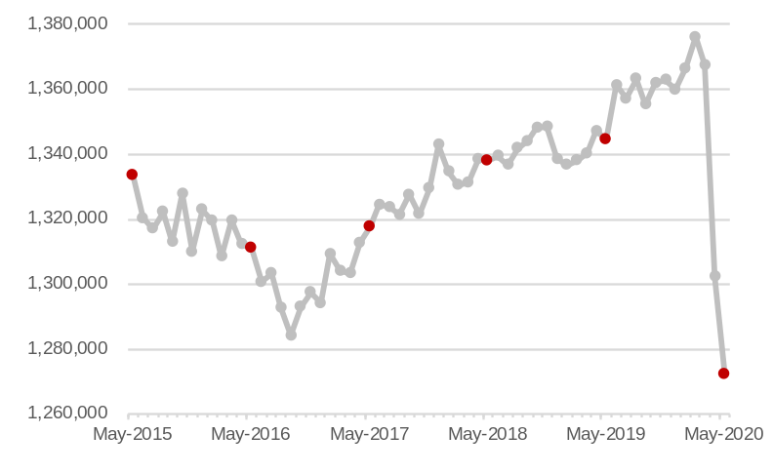
Note – Vertical axis does not start at zero. ¹ Worked 35 hours or more a week. ² Worked less than 35 hours a week.
Source: ABS 6202.0 Labour Force, Australia.

Hours worked: Monthly (Seasonally adjusted)¹ | - Western Australia’s total hours worked recovered slightly in May 2020.  - Actual hours worked in all jobs rose 2.1% (3.6 million) to 173.7 million in May 2020.  - Average hours worked per employed person rose 4.6% in May 2020.  - The industries with the largest increases in actual hours worked between May 2019 and 2020 were public administration and safety; rental, hiring and real estate services; and utilities.  - The industries with the largest decreases in actual hours worked between May 2019 and 2020 were manufacturing; accommodation and food services; and transport, postal and warehousing.
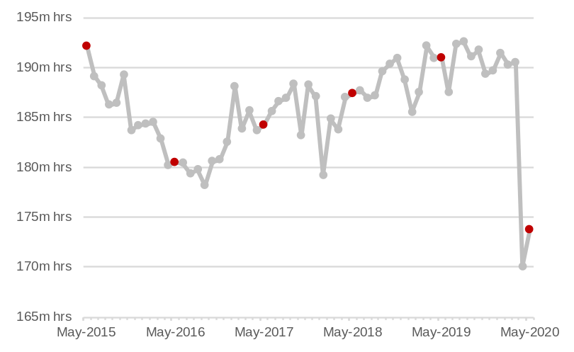
Note – Vertical axis does not start at zero. ¹ Total monthly hours worked in all jobs (full time and part time jobs).
Source: ABS 6202.0 Labour Force, Australia.

Participation rate: Monthly (Seasonally adjusted) | - The participation rate is the proportion of the civilian working age population employed or actively looking for work.  - Western Australia’s participation rate fell from 65.1% in April 2020 to 65.0% in May 2020.  - The fall in the participation rate reflects that the total labour force fell by 2,296 people in May 2020.  - While deteriorating job prospects drove the fall in the participation rate in recent months, the Australian Government’s JobSeeker payment also had an effect by not requiring recipients to look for work until 1 June. If people are not actively looking for work, they are classified as ‘not in the labour force’ rather than ‘unemployed’.
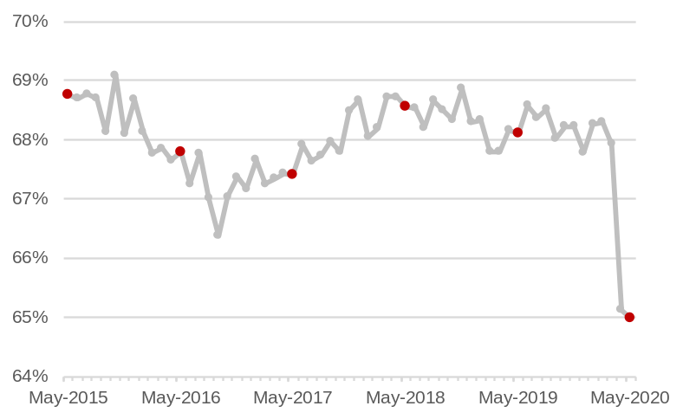
Note – Left vertical axis does not start at zero.
Source: ABS 6202.0 Labour Force, Australia.

LABOUR MARKET

Unemployment rate¹: Monthly (Seasonally adjusted) | - Western Australia’s unemployment rate recorded its largest monthly rise in May 2020.  - The unemployment rate rose from 6.1% in April 2020 to 8.1% in May 2020 – the highest rate since June 2001.  - The number of unemployed people rose 33% (27,944) to 112,170 in May 2020, following a rise of 8% (6,040) in April 2020.  - The industries will the largest increases in unemployed people² between May 2019 and 2020 were accommodation and food services (up 6,193), education and training (up 5,536), administration and support (up 3,985) and construction (up 3,946).
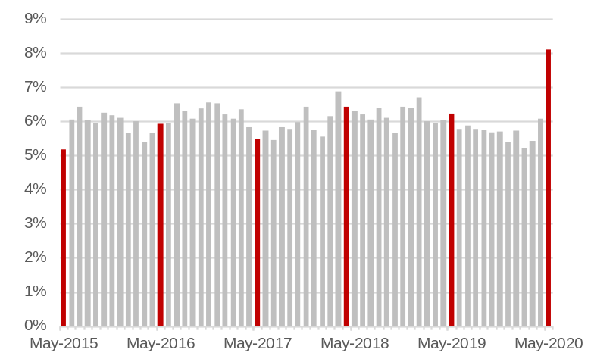
¹ The unemployment rate is the proportion of the labour force actively looking for a job. ² Industry of last job.
Source: ABS 6202.0 Labour Force, Australia.

Underemployment rate¹: Monthly (Seasonally adjusted) | - The number of Western Australians wanting to work more hours fell in May 2020 as some people increased their hours of work following the easing of some restrictions.  - The underemployment rate fell from 14.4% in April 2020 to 12.1% in May 2020.  - The number of underemployed people fell 16% (32,584) to 167,624 in May 2020, following a rise of 43% (60,134) in April 2020.  - The underutilisation rate, which comprises the unemployment and underemployment rates, fell from 20.5% in April 2020 to 20.2% in May 2020.
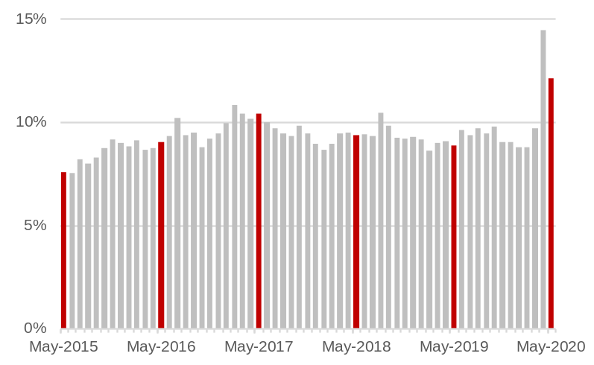
¹ The underemployment rate is the proportion of the labour force with a job but wanting to work more hours.
Source: ABS 6202.0 Labour Force, Australia.

Internet vacancies: Monthly (Seasonally adjusted)¹ | - The monthly Internet Vacancy Report is based on a count of online job advertisements newly lodged on SEEK, CareerOne and Australian JobSearch during the month and provides a leading indicator of employment.  - Western Australia’s internet vacancies rose 29% (2,439) to 10,720 in May 2020, following a fall of 35% (4,505) in April 2020.
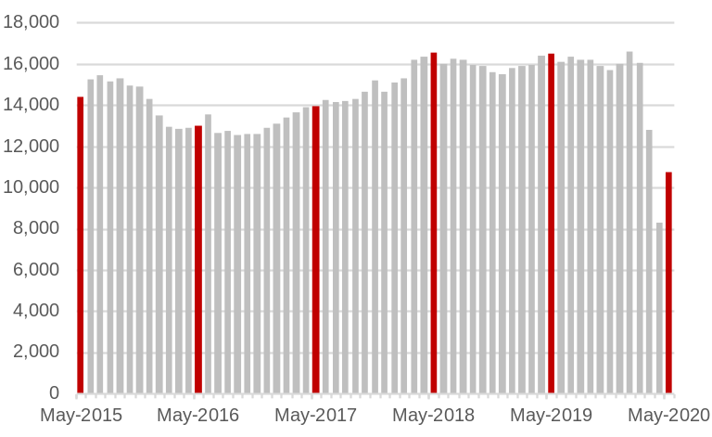
¹ Online job advertisements on SEEK, CareerOne and Australian JobSearch. Excludes job advertisements on other online job boards, employer web sites, newspapers and word of mouth.
Source: Department of Education, Skills and Employment, Vacancy Report.

INTERNATIONAL TRADE

Exports of goods: Monthly (Original)¹ | - Western Australia’s exports reached an all-time monthly high of $17.7 billion in March 2020.  - The value of Western Australia’s merchandise exports was $15.4 billion in April 2020, 9% higher than April 2019.  - The value of Western Australia’s iron ore exports was $8.5 billion in April 2020, 12% higher than April 2019.  - The value of other (non-iron ore) goods exports was $6.9 billion in April 2020, 6% higher than April 2019.
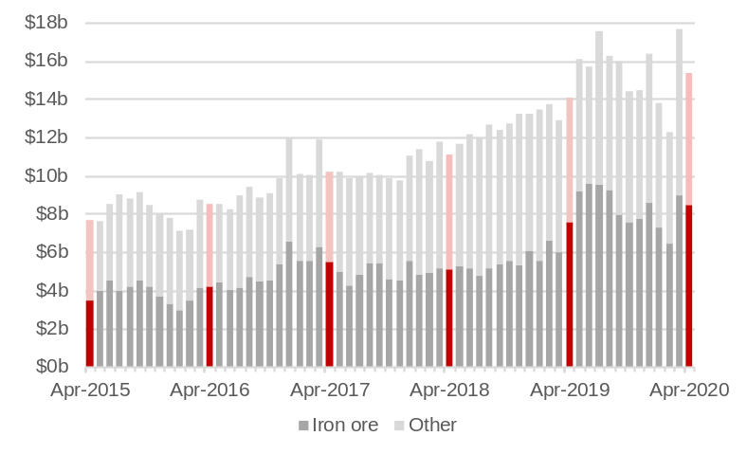
¹ Free on board. Current prices.
Source: ABS 5368.0 International Trade in Goods and Services.

Imports of goods: Monthly (Original)¹ | - The value of Western Australia’s imports was $2.6 billion in April 2020, 9% higher than April 2019.  - The largest increases in the value of Western Australia’s major imports² between April 2019 and 2020 were in:  - Machinery and transport equipment (up 13% to $862 million).  - Chemicals (up 62% to $253 million).  - Gold (up 10% to $239 million).  - The value of Western Australia’s petroleum imports fell 17% to $484 million between April 2019 and 2020, due to a lower oil price.
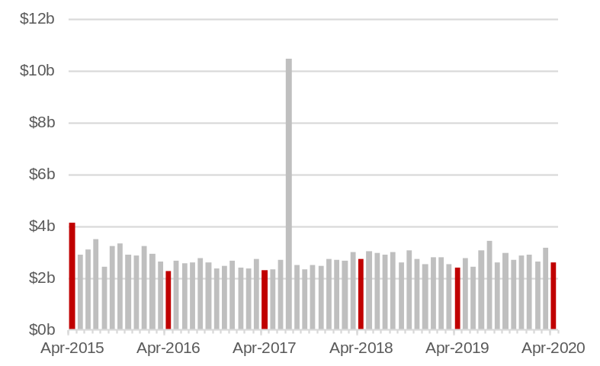
Note – The large value of imports in July 2017 was mainly due to the arrival of the Prelude Floating LNG Plant. ¹ Customs value. Current prices. ² Excluding confidential items.
Source: ABS 5368.0 International Trade in Goods and Services.

Overseas visitors: Monthly (Original)¹ | - Travel was restricted to and around Western Australia in the effort to contain the spread of COVID-19, resulting in a large fall in overseas visitors.  - Western Australia had 250 short-term overseas visitors arriving in April 2020, 99.6% (62,610) lower than April 2019.  - There were 39,142 international students enrolled in Western Australia in April 2020, 5% (1,871) more than April 2019. While many students arrived in the State before travel was restricted, ongoing travel restrictions will affect the number of international student enrolments throughout the year.
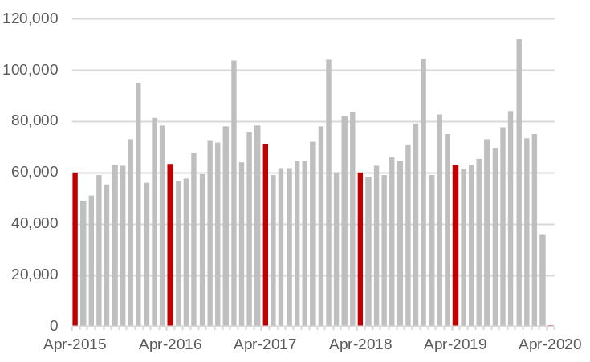
¹ Short-term (less than a year) overseas visitor arrivals.
Source: ABS 3401.0 Overseas Arrivals and Departures, Australia.

RETAIL TRADE AND PROPERTY CONSTRUCTION

Retail turnover: Monthly (Seasonally adjusted)¹ | - Western Australia recorded its largest monthly fall in retail trade in April 2020, following the largest monthly rise in March 2020.  - Retail trade fell 17% to $2.69 billion in April 2020, following a rise of 10% in March 2020. The fall in retail trade was due to decreases across all groups.  - Food – down 18% to $1.29 billion.  - Cafes, restaurants and takeaway food – down 24% to $310 million.  - Other retailing² – down 15% to $394 million.  - Clothing, footwear and personal accessories – down 59% to $49 million.  - Department stores – down 13% to $134 million.  - Household goods – down 2% to $510 million.
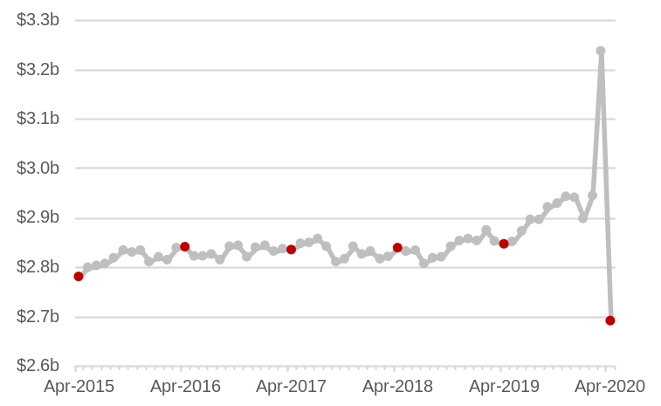
Note – Vertical axis does not start at zero. ¹ Current prices. ² Includes newspapers and books; other recreational goods; pharmaceutical, cosmetic and toiletry goods; and other retailing.
Source: ABS 8501.0 Retail Trade, Australia.

Dwelling approvals: Monthly (Seasonally adjusted)¹ | - Leading indicators suggest there will be sustained housing construction activity in Western Australia over the next few months, with downward pressure thereafter.  - The number of dwelling approvals rose 12% to 1,350 in April 2020, following a rise of 2% in March 2020.  - The value of building approvals fell 13% to $684 million in April 2020, following a rise of 18% in March 2020. In April 2020, the value of approvals for:  - Residential building rose 5% to $427 million.  - Non-residential building fell 32% to $257 million.
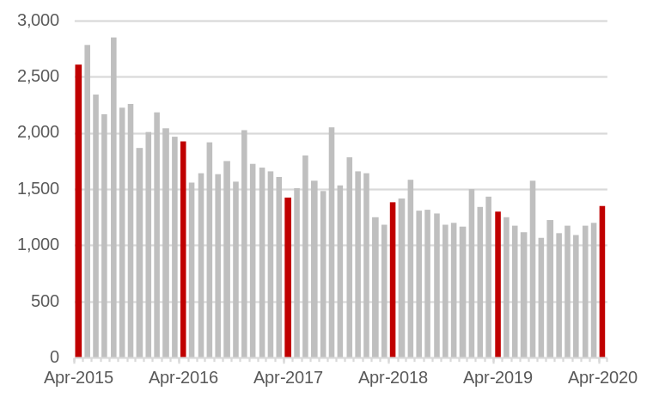
¹ Number of house and other dwelling approvals.
Source: ABS 8731.0 Building Approvals, Australia.

Housing finance: Monthly (Original)¹ | - The value of Western Australia’s housing finance commitments was $1.1 billion in April 2020, 7% lower than in April 2019.  - Between April 2019 and 2020, housing finance commitments for:  - Owner-occupiers fell 4% to $949 million.  - Investors fell 22% to $168 million.  - The value of fixed-term loans to small and medium sized businesses for constructing or purchasing property was $166 million in April 2020, 12% lower than March 2020.²
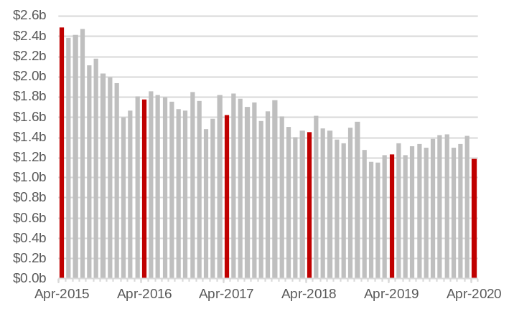
¹ Value of new loan commitments for housing (excluding refinancing) by owner-occupiers and investors. ² Not adjusted for seasonal factors.
Source: ABS 5601.0 Lending Indicators, Australia.

